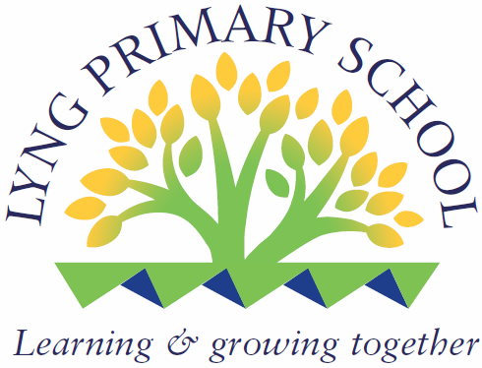

Lyng Primary School
Personnel Specification for Teacher

Post Title  Teacher | School/Centre  Lyng Primary School | Completed by Victoria Durnall  Date 02.02.2025

The Personnel Specification aims to provide a clear picture of the person you want to carry out the post. It should record the main attributes which the person needs and should be drawn from a critical examination of the job description.

NOTES:

It is expected that all applicants for teaching posts will have the following general attributes:

Basic teaching qualification
Basic teaching skills
Disposition factors (eg ability to relate to others, ability to organise, caring,
co-operative, etc.)

It is therefore not necessary to ask for these when completing the personnel specification. However, specific criteria should be stated when required, eg for a post which carries a specific responsibility.

 | Essential Requirements | N/A | How Identified
1. Physical  Consider the real needs of the post. Be particularly wary about setting limits which actively discriminates against specific age groups and disabled people. | To be smartly dressed and have a professional appearance.  Professional manner.  Have general good health and a positive attendance record.  Be able to communicate effectively and with clarity. |  | Job History from application form and reference. Performance on interview process. Sickness/Medical History information will be obtained from successful candidate after conditional offer of employment has been made.
2 Qualifications/Relevant Experience  What does the post require in the way of: level of formal qualifications/relevant experience. Describe these by level of attainment and by subject matter where appropriate or appropriate subject related qualification/ relevant experience (for unqualified teachers) and/or supplementary qualifications (for teachers of the deaf etc.) | All teachers to have received a grade C (or equivalent) in GCSE English and Maths.  To hold a degree/ equivalent qualification with QTS.  Experience of teaching in KS2.  Knowledge of the KS2 curriculum  Knowledge of end of KS2 testing  An ability to use ICT effectively both to support children's' learning and to evaluate learning.  Ability to add to the ethos of the school. |  | Formal possession of an appropriate qualification to be verified at interview or from records. Employment history record.

 | Essential Requirements | N/A | How Identified
3. Training/Special Knowledge  What does the post require in the way of: specific and/or specialist training/knowledge eg counselling, pastoral care, interpersonal skills. Practical training in the use of specific equipment. | Knowledge and experience of delivering the Primary National Strategy, Assessment procedures and National Curriculum.  Evidence of involvement in assessment and use of data.  Good interpersonal skills to help promote positive relationships with all stakeholders.  Phonic experience  SPAG experience |  | Past training employment history from application form and records. Selection process by demonstration of ability to display knowledge and skills at the interview.
4. Circumstances (Personal)  What kind of personal circumstances are required eg the ability to work unsociable hours, weekends, etc. Willingness to live in if the post requires (residential centres). Ability to travel to various locations. | Ability to work as directed by the Headteacher in accordance with 1265 hours per year directed time. |  | Ensuring candidates are aware of these requirements from the post description. Interview questions and application form details.
5. Practical and Intellectual  What practical and intellectual skills are required for performing the duties of the post effectively eg, does the person need to be a practically oriented person, should they be able to make decisions, should they be able to understand, interpret, write and communicate information. What degree of manual dexterity is needed. | The ability to work as part of a team.  The experience and ability to deal positively with parents and children  The ability to manage behaviour effectively.  A commitment to raising standards Appointed member of staff expected to conform and uphold all school policies and procedures, specifically those relating to Safeguarding, Child Protection and Quality Assurance systems and procedures. |  | Performance in related selection process.
6. Any other additional requirements specific to this post. | Vetting & Barring Scheme Regulated Activity Registration and Enhanced DBS Disclosure Check required.  GTC Registration.

